FINLEY MIDDLE SCHOOL
MUSIC DEPARTMENT

Frank Battista Matt Gelfer Daniel Santangelo Christopher Scarnato
Band Orchestra Chorus Band

June 5th, 2018

Dear Students and Parents,
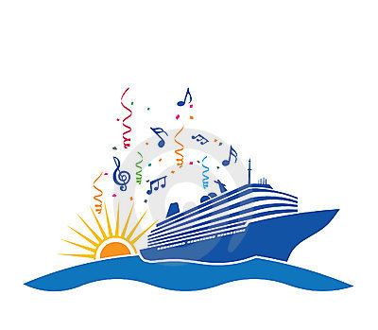
The J. Taylor Finley Music Honors Ensemble trip will take place on Thursday, June 7th on the party boat “The Moon Chaser” out of Captree State Park.

The Moon Chaser trip includes:
*Three hour boat cruise
* Bus transportation to and from Finley Middle School
*Catered hot/cold food, soft drinks & dessert
*DJ Richie
* Commemorative Finley honors ensemble t-shirt

Thursday, June 7th Itinerary
3:15 pm – Buses leave Finley
4:00 pm – Arrive at Captree State Park
4:15 pm – Board the Moon Chaser
7:15 pm – Boat arrives at dock (Captree State Park)
7:30 pm – Board buses
8:15 pm – Arrive at Finley Middle School

No further payment is necessary at this time.
Please Sign and Return Entire Document.

THE UNDERSIGNED FURTHER AGREES TO SAVE HARMLESS THE HUNTINGTON UNION FREE SCHOOL DISTRICT, ITS OFFICERS, AGENTS, SERVANTS, EMPLOYEES AND ENUMERATED VOLUNTEERS, FROM ANY AND ALL LIABLITY FOR ANY PERSONAL INJURIES OR PROPERTY DAMAGES SUFFERED. THE UNDERSIGNED FURTHER AGREES TO HOLD THE HUNTINGTON UNION FREE SCHOOL DISTRICT HARMLESS FROM ANY CLAIMS MADE BY ANY PERSON FOR ANY LOSS OR DAMAGE OR INJURY RESULTING FROM OR ARISING OUT OF ANY ACTS OR OMISSIONS OF THE UNDERSIGNED OR ANY OTHER PERSONS ACTING ON BEHALF OF THE UNDERSIGNED, WITH REGARDS TO OR IN CONNECTION WITH THE EVENT.

I give permission for my son/daughter _______________________to go on the Moon Chaser boat trip on Thursday, June 7th 2018.

Signature of Parent/Guardian ____________________

